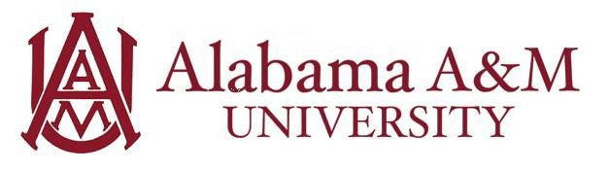

Job Title: Student Equipment Assistant
Department: Varies (Athletics, Bands, or other campus departments)
Hourly Rate: $12/hour
Work Hours: Up to 20 hours per week (flexible with class schedule)

Position Summary:
The Student Equipment Assistant will provide logistical, operational, and administrative support to their assigned department, such as Athletics, Bands, or other university programs. Responsibilities include assisting with the organization, distribution, maintenance, and inventory of equipment, uniforms, and supplies to ensure smooth daily operations, practices, performances, competitions, and travel. This role offers hands-on experience in equipment management, operational logistics, and program administration within a collegiate environment.

Purpose and Learning Outcomes:
- Understand logistical, operational, and administrative functions within a collegiate department.
- Learn inventory management practices and how to maintain, repair, and distribute equipment and uniforms.
- Gain experience supporting event, practice, performance, and game-day operations and travel preparation.
- Strengthen organizational, time management, and teamwork skills.
- Develop an understanding of equipment safety, cleanliness, and departmental compliance standards.
- Cultivate effective communication and customer service skills when interacting with students, staff, faculty, and stakeholders.

Key Responsibilities:
- Assist with issuing, labeling, collecting, and maintaining uniforms, equipment, instruments, and practice gear.
- Prepare and pack equipment for practices, rehearsals, performances, competitions, and travel.
- Support setup and breakdown for departmental events, practices, and performances.
- Operate laundry equipment or perform basic cleaning and maintenance to ensure gear and uniforms remain in usable condition.
- Track and maintain accurate inventory records of equipment, apparel, instruments, and supplies.
- Report equipment repairs, losses, or discrepancies promptly to supervisors.
- Assist with administrative or clerical tasks, such as maintaining student records, managing schedules, or preparing documentation, as needed.
- Maintain cleanliness and organization of workspaces, including equipment rooms, storage areas, laundry facilities, practice rooms, and locker rooms.
- Provide courteous, professional service and act as a point of contact for operational questions, directing inquiries appropriately.

Qualifications:
Preferred knowledge, skills, and personal qualifications:
- Interest in sports management, music, operations, or related fields.
- Basic knowledge of equipment or instrument care, uniforms, and safety protocols.
- Strong organizational skills and attention to detail.
- Previous experience in athletics, band, logistics, or customer service (including volunteer experience).
- Proactive, self-motivated, and able to work effectively in a dynamic, fast-paced environment.
- Ability to lift 40–50 lbs safely and stand for extended periods.

Required Qualifications:
- Must be a currently enrolled undergraduate or graduate student at Alabama A&M University.
- Minimum cumulative GPA of 2.5.
- Ability to work flexible hours, including early mornings, evenings, weekends, and some holidays.
- Dependable, detail-oriented, and capable of working independently or as part of a team.
- Strong communication skills and a commitment to confidentiality and professionalism.

Experience Gained in this Role:
By the end of the employment period, the student will have developed skills in:
- Communication: The student will be able to communicate clearly, answer questions effectively, and direct inquiries to the correct person or department.
- Teamwork: The student will be able to collaborate efficiently with staff and peers to support departmental goals.

