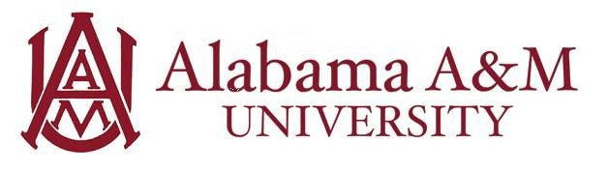

Job Title: Communications Student Employee
Department: Department of Athletics
Hourly Rate: $12/hour
Work Hours: Up to 20 hours per week (flexible with class schedule)

Position Summary:
The Communications Student Employee will assist the Department of Athletics in promoting the university’s athletic programs through digital content, press coverage, and media relations. This role supports the department’s mission by ensuring timely, accurate, and compelling coverage of athletic events, student-athlete achievements, and departmental milestones. The position provides a unique opportunity for students interested in sports communications, journalism, public relations, or digital media to gain hands-on experience in a fast-paced, NCAA Division I environment.

Purpose and Learning Outcomes:
- Gain experience in sports writing, media relations, and content creation for a collegiate athletic department.
- Learn how to manage communication platforms, including official websites, social media, and press releases.
- Understand the importance of storytelling in promoting athletic success and university branding.
- Strengthen interview, writing, and public speaking skills in a professional setting.
- Build a portfolio of published work related to sports journalism and digital media production.

Key Responsibilities:
- Assist with game-day coverage including live stats, social media updates, photography, and postgame recaps.
- Draft and edit press releases, feature stories, game notes, and student-athlete profiles.
- Help maintain and update the athletics website with schedules, results, and media content.
- Support media coordination and credentialing for home events and press conferences.
- Collaborate on social media strategy and assist with producing video and graphic content.
- Archive game results, rosters, and statistical data for departmental and NCAA record-keeping.

Qualifications:
Preferred knowledge, skills, and personal qualifications:
- Pursuing a major in Communications Media, Sport Management, or a related field.
- Strong writing and editing skills
- Experience with social media platforms, content scheduling tools, and/or website content management systems.
- Familiarity with sports statistics, terminology, and media coverage formats.

Required Qualifications:
- Must be a currently enrolled undergraduate or graduate student at Alabama A&M University.
- Minimum cumulative GPA of 2.5.
- Strong verbal and written communication skills.
- Willingness to work evenings and weekends to cover athletic events.
- Professionalism, reliability, and attention to detail.

Experience Gained in this Role:
By the end of the employment period, the student will have developed skills in:
- Professionalism – The student will gain an understanding of how to develop and maintain professional relationships with media outlets.
- Critical Thinking – The student will be able to tailor content to specific platforms and target audiences.

